

**BA 385T – Financial Management – Accounting Portion – Fall 2023**

**Instructor – Brian Lendecky (**[**Brian.Lendecky@mccombs.utexas.edu**](mailto:Brian.Lendecky@mccombs.utexas.edu)**)**

**copyright © 2023 Brian Lendecky (DISTRIBUTION IN ANY FORM IS PROHIBITED)**

**Class #1 - Monday August 21**

**Topic #1 – Basics in Cost Behavior**

**This packet of class notes is copyrighted and created for the exclusive use in classes at The McCombs School of Business.** Any copying or distribution of this packet (electronically or hard copy) is a violation of federal law and will result in disciplinary actions being taken against the student.  Additionally, the sharing, uploading, downloading, and/or distribution of this packet (including, but not limited to, Slack, Chegg, Course Hero, social media sites, etc.) is a violation of the University's Student Honor Code and an act of academic dishonesty, which will result in further disciplinary action. This above also applies to McCombs students who download this material *from* Chegg, Course Hero, Slack, social media sites, etc. The following quote is from Chegg (Course Hero & other sites have similar policies): *“If you have concerns that students may be using our products inappropriately, Chegg is here to work with you and address your concerns. We will cooperate with any investigation by an academic instruction.”* I frequent Chegg, Course Hero, and other similar sites. I will and have contacted these sites in the past and they have been cooperative in providing me the name of students who downloaded and/or uploaded my material, which I then used to file McCombs academic dishonesty grievances. IT’S NOT WORTH IT! ALL acts of academic dishonesty receive significant penalties and are reported to Student Judicial Services and attach to your record.

**Cost Behavior – the relationship between cost and activity**

Cost Driver – any event or activity that causes costs to be incurred.

Variable Costs – costs that increase or decrease in total in direct proportion to a change in activity of the cost driver. The cost per unit remains constant.

Example 1 – the total cost of steering wheels for the Toyota plant varies with the number of Toyotas (cost driver) made. However, the steering wheel cost *per* Toyota will NOT vary depending on the amount of Toyotas made.

Example 2 – the paper cost of tests will vary with the number of students a professor has in their class.

The cost driver of a variable cost is the level of activity or volume whose change causes proportionate changes in the variable cost.

Let’s look at the chart on the next page!

Fixed Costs – these costs remain constant in total as the level of activity changes (within a given relevant range). Cost per unit increases or decreases due to changes in activity level.

Example 1 – the salary of the Toyota Tundra line manager is fixed no matter how many Tundras are made. However, the salary cost *per* Tundra will vary depending on the amount of Tundras made.

Example 2 – My salary for this class. My salary for this class is fixed no matter how many students are enrolled or show up to this class. However, my salary cost per student will vary depending on class size.

What is a relevant range?

The range of activity within which management expects the company to operate. In other words, the range of units for which the cost is fixed.

Let’s look at the charts two pages back!

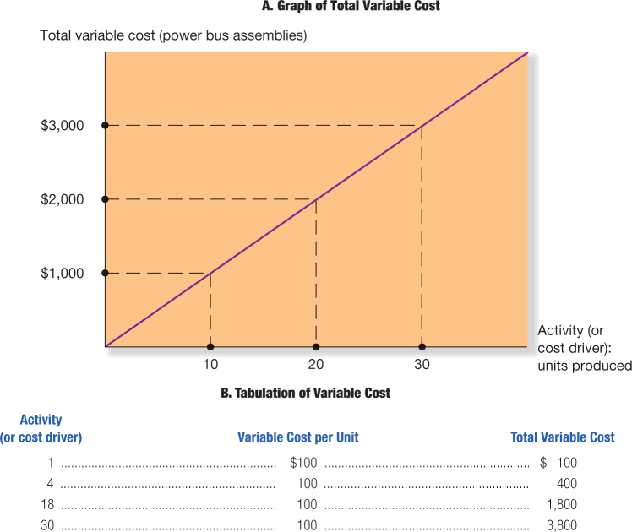

The $3800 above is supposed to be $3,000

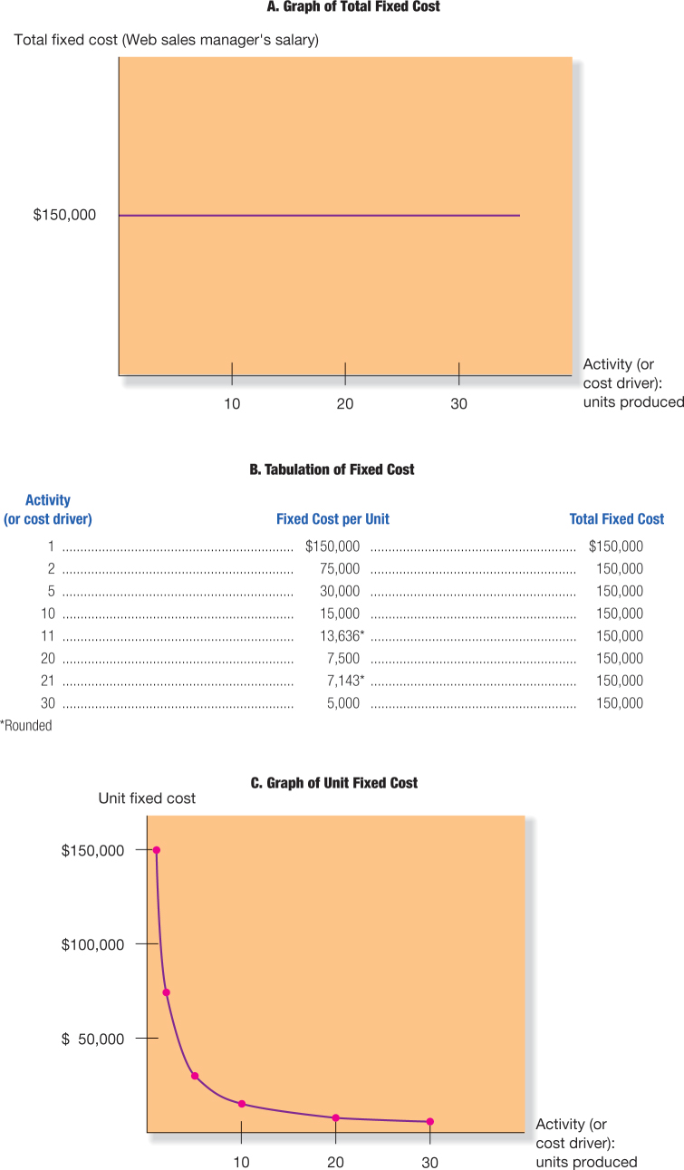

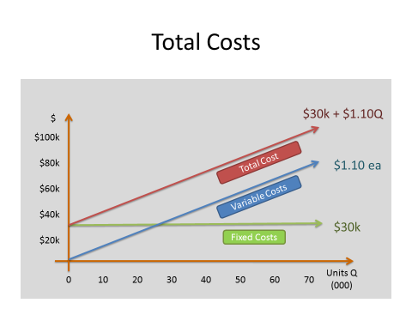

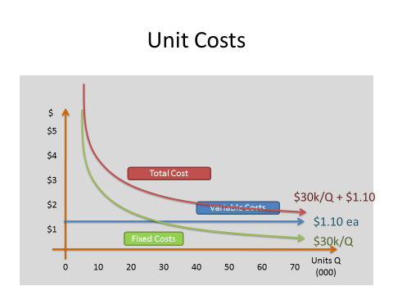

Example - Blue Bell sells each half-gallon carton of ice cream (from Blue Bell to grocery chain, delivered) for $2.50 each.

In December, Blue Bell produced and sold 80,000 cartons at an average cost of $2.00 per carton.

(FYI - Total variable costs equaled $120,000, total fixed costs equaled $40,000).

What was Blue Bell’s profit in December?

80,000 cartons x ($2.50 – $2.00) = $40,000

This coming June, Blue Bell plans to sell 150,000 cartons. How much profit will they have?

150,000 x ($2.50 – $2.00) = $75,000 NO!

Variable Costs = $120,000 / 80,000 cartons = $1.50 per carton

Fixed Costs = $40,000

June profit =

Sales $2.50 x 150,000 cartons $375,000

Variable Costs $1.50 x 150,000 cartons <$225,000>

Fixed Costs <$40,000>

$110,000

The above Blue Bell example is a good example of the pitfalls of using unit costs instead of total costs.

Generally, the decision maker should think in terms of total costs rather than unit costs. But, decision makers need to also consider activity levels, so managerial accounting reports often report costs per unit. Unit costs are very important, but be VERY careful when computing and analyzing.

Units costs for predicting the future are only good when production levels stay the same!

Why? Because of fixed costs!

(FYI – missed homework and exam questions often are the result of students not being careful when analyzing unit costs!!)

*Key Concept*…

Total contribution margin – the difference between all revenues and all variable costs.

Unit contribution margin – the difference between the product’s sales price and its variable unit cost.

The unit contribution margin is the amount that profits increase (or decrease) when we produce and sell one additional (or one less) “unit” of either a product or service.

So, why is it called contribution margin?

For every additional “unit” we sell, the unit contribution margin contributes that amount to increasing our profit. The opposite is true for every “unit” *less* we sell.

Mixed cost (or semi-variable) – contains both fixed and variable components.

Examples – 1) Most salespeople are compensated with a salary (fixed) and a sales commission (variable). 2) Electricity.

Step-variable costs – are nearly variable. Step-variable costs increase in small steps rather than in direct proportion (continuously) to cost-driver changes.

Example – Wait staff at a restaurant

Let’s look at the graph on the next page.

**Step-Variable Cost Graph**

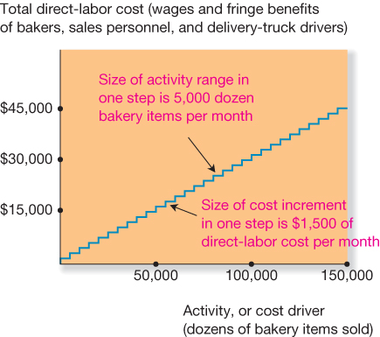

Big Picture - Why is understanding cost behavior important?

To plan – example: making budgets

To control – you better figure out *quickly* what is going on if costs are not behaving as expected.

To make decisions – should we offer a new product? add a new product line? close down a portion of the plant?

How can you make a decision about your business if you don’t know how your costs behave?

For every decision a company makes, it has to know how much revenue will be earned and what costs will be incurred from making that decision.